**Network Namespace Simulation Assignment**

**Task 1: Create Network Bridges**

    sudo ip link add dev br0 type bridge;

    sudo ip link add dev br1 type bridge;

    sudo ip link set dev br0 up;

    sudo ip link set dev br1 up;

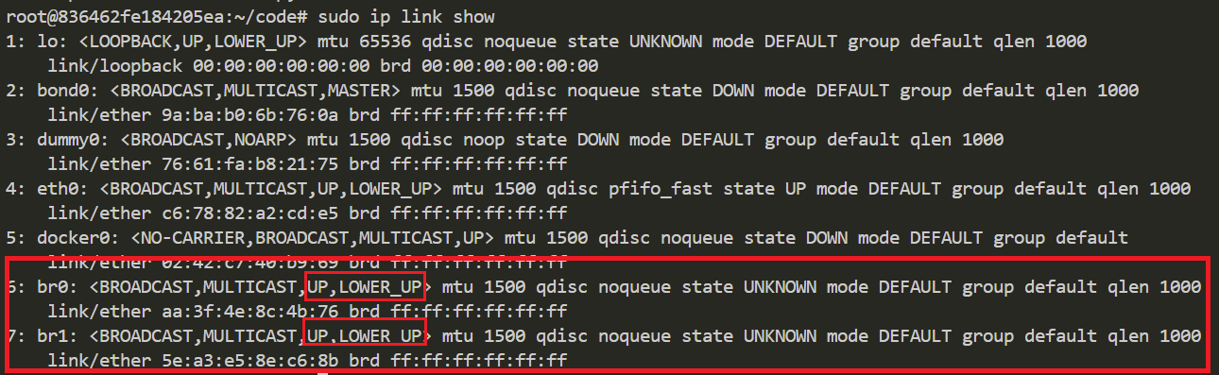

**Task2: Create Network Namespaces**

    sudo ip netns add ns1;

    sudo ip netns add ns2;

    sudo ip netns add router-ns;

**Task3: ⁠Create Virtual Interfaces and Connections**

#create interfaces with correct pair

    sudo ip link add veth-ns1 type veth peer name veth-br0;

    sudo ip link add veth-ns2 type veth peer name veth-br1;

    sudo ip link add vr-br0 type veth peer name vr-ns1;

    sudo ip link add vr-br1 type veth peer name vr-ns2;

#connect interfaces to correct namesapce and bridges

    sudo ip link set dev veth-ns1 netns ns1;

    sudo ip link set dev veth-br0 master br0;

    sudo ip link set dev veth-ns2 netns ns2;

    sudo ip link set dev veth-br1 master br1;

    sudo ip link set dev vr-br0 master br0;

    sudo ip link set dev vr-ns1 netns router-ns;

    sudo ip link set dev vr-br1 master br1;

    sudo ip link set dev vr-ns2 netns router-ns;

Interfaces for the bridge

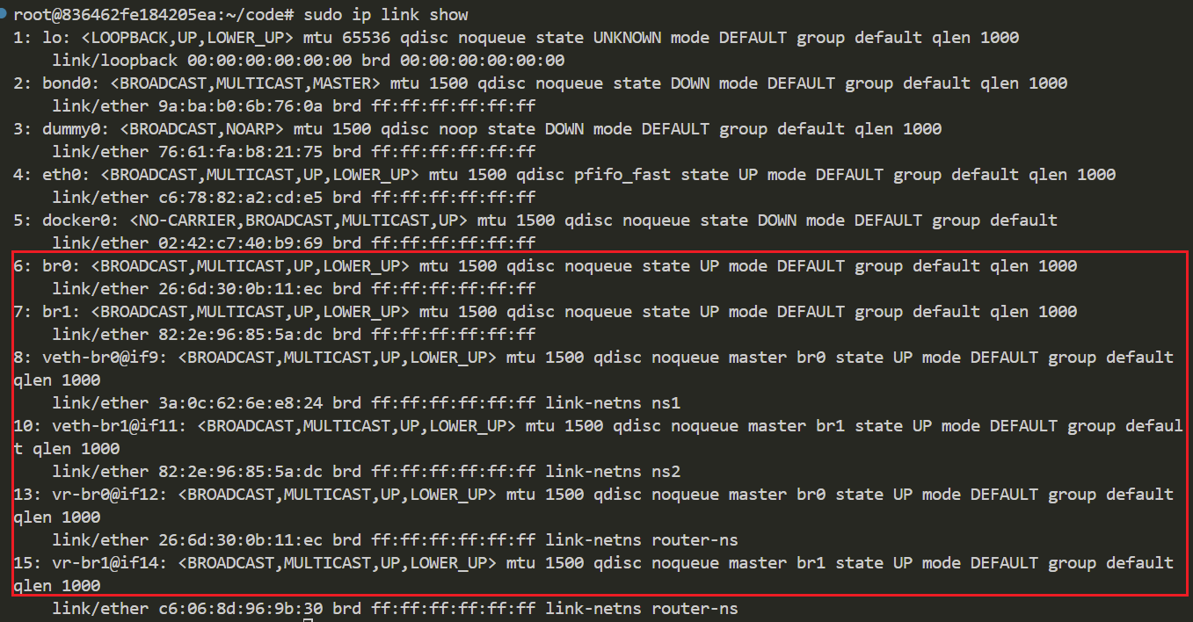

Interfaces in the namespaces:

**Task4: Configure IP Addresses**

    sudo ip address add 10.11.0.1/24 dev br0;

    sudo ip address add 10.11.0.3/24 dev vr-br0;

    sudo ip address add 10.12.0.1/24 dev br1;

    sudo ip address add 10.12.0.3/24 dev vr-br1;

    sudo ip netns exec ns1 ip address add 10.11.0.2/24 dev veth-ns1;

    sudo ip netns exec ns2 ip address add 10.12.0.2/24 dev veth-ns2;

    sudo ip netns exec router-ns ip address add 10.13.0.2/24 dev vr-ns1;

    sudo ip netns exec router-ns ip address add 10.13.0.3/24 dev vr-ns2;

IP address assignment for bridge interfaces

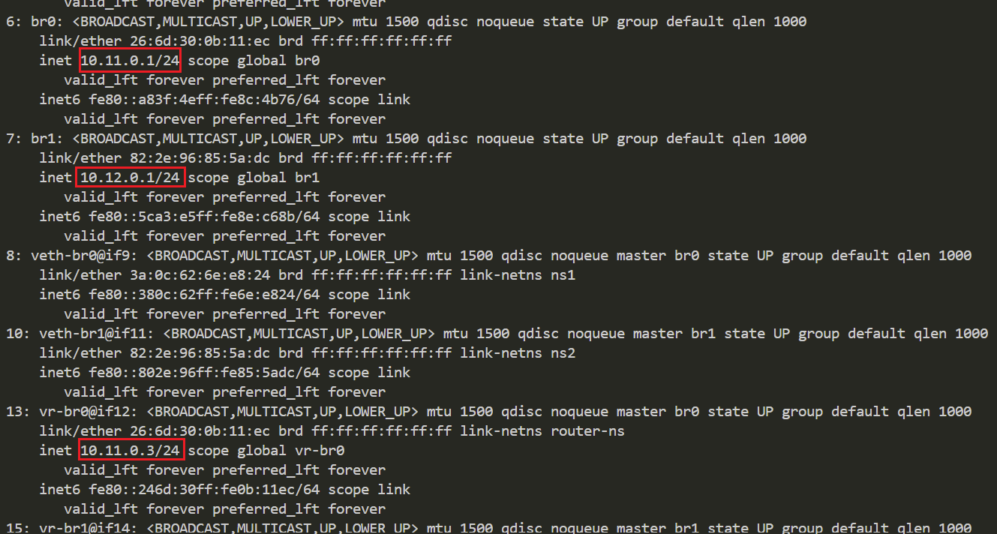

IP assignment for namespace interfaces

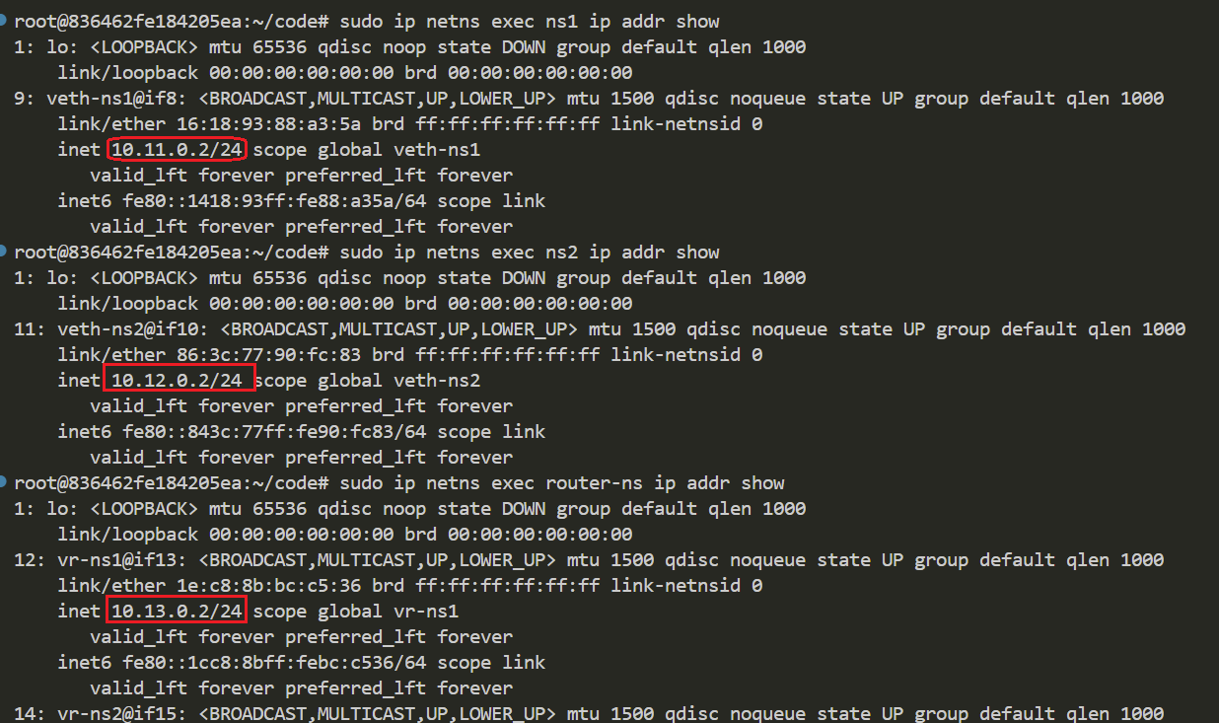

**Task5: Setup routing**

#default route in namespace

    sudo ip netns exec ns1 ip route add default via 10.11.0.1;

    sudo ip netns exec ns2 ip route add default via 10.12.0.1;

#routing in the bridge to make sure traffice route to the different network

    ip route add 10.12.0.0/16 dev vr-br0;

    ip route add 10.11.0.0/16 dev vr-br1;

#routing between network in router-ns

    sudo ip netns exec router-ns ip route add 10.11.0.0/16 dev vr-ns1;

    sudo ip netns exec router-ns ip route add 10.12.0.0/16 dev vr-ns2;

#enabling IP forwarding

    sudo iptables --append FORWARD --in-interface br0 --jump ACCEPT;

    sudo iptables --append FORWARD --out-interface br0 --jump ACCEPT;

    sudo iptables --append FORWARD --in-interface br1 --jump ACCEPT;

    sudo iptables --append FORWARD --out-interface br1 --jump ACCEPT;

**Task6: Test Connectivity**

